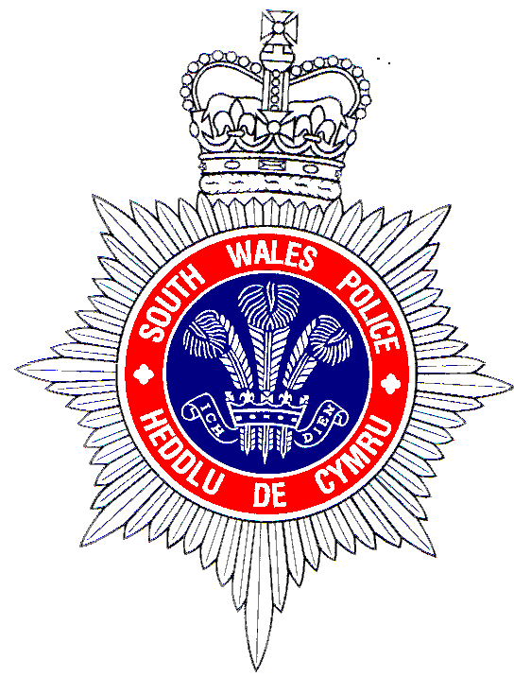

Firearms Licensing Application Fees

FIREARMS CERTIFICATES |  | COST
Grant of a firearm certificate |  | £88
Renewal of a firearm certificate |  | £62
Variation of a firearm certificate (other than when it is renewed at the same time) to increase the number of firearms to which the certificate relates |  | £20
Replacement of a firearm certificate lost or destroyed |  | £4
Renewal applications received after the certificate has expired will be charged the full grant fee
Payment by Cheque and Postal Order only. To be made payable to | The Police & CC for South Wales
Please return completed application forms to | South Wales Police,  Firearms Licensing, Data Management & Disclosure Unit, Police Headquarters, Cowbridge Road, Bridgend. CF31 3SU

SHOT GUN CERTIFICATES |  | COST
Grant of a shot gun certificate |  | £79.50
Renewal of a shot gun certificate |  | £49
Replacement of a shot gun certificate lost or destroyed |  | £4
Renewal applications received after the certificate has expired will be charged the full grant fee

Payment by Cheque and Postal Order only. To be made payable to | The Police & CC for South Wales
Please return completed application forms to | South Wales Police,  Firearms Licensing, Data Management & Disclosure Unit, Police Headquarters, Cowbridge Road, Bridgend. CF31 3SU

COTERMINOUS SHOT GUN CERTIFICATES |  | COST
Grant of a firearm certificate and grant of a shot gun certificate applying at the same time |  | £90
Grant of a firearm certificate and renewal of a shot gun certificate applying at the same time |  | £90
Renewal of a firearm certificate and grant of a shot gun certificate applying at the same time |  | £90
Renewal of a firearm certificate and renewal of a shot gun certificate applying at the same time |  | £65
Replacement of a shot gun certificate or firearms certificate |  | £4 per certificate
Renewal applications received after the certificate has expired will be charged the full grant fee
Payment by Cheque and Postal Order only. To be made payable to | The Police & CC for South Wales
Please return completed application forms to | South Wales Police,  Firearms Licensing, Data Management & Disclosure Unit, Police Headquarters, Cowbridge Road, Bridgend. CF31 3SU

REGISTERED FIREARMS DEALERS |  | COST
Initial registration of a firearms dealer |  | £200
Renewal of registration |  | £200
Dealers registering in other force areas specifically to trade at game fairs or similar events |  | £13
Payment by Cheque and Postal Order only. To be made payable to | The Police & CC for South Wales
Please return completed application forms to | South Wales Police,  Firearms Licensing, Data Management & Disclosure Unit, Police Headquarters, Cowbridge Road, Bridgend. CF31 3SU

VISITORS PERMIT |  | COST
Visitors firearm & shot gun permit |  | £20
Group Visitors firearm & shot gun permit (6 or more applicants) |  | £100
Payment by Cheque and Postal Order only. To be made payable to | The Police & CC for South Wales
Please return completed application forms to | South Wales Police,  Firearms Licensing, Data Management & Disclosure Unit, Police Headquarters, Cowbridge Road, Bridgend. CF31 3SU

